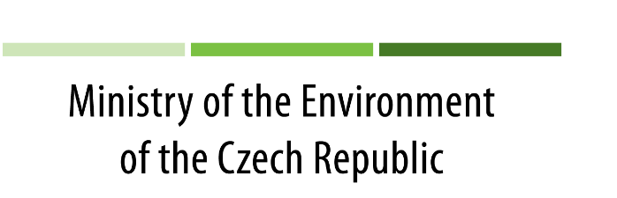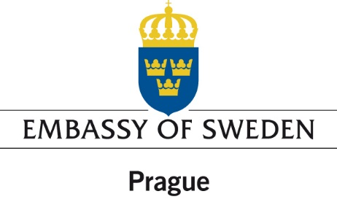
Czech – Swedish
Seminar
The Circular Economy and Benefits for Society
Jobs and Climate Clear Winner in an Economy Based on
Renewable Energy and Resource Efficiency

Ministry of the Environment of the Czech Republic
21. 11. 2016, 13:00
Conference room nr. 900
Timetable
13:00 – 13:10 Opening Remarks
Vladislav Smrž, Deputy Minister
Viktoria Li, Ambassador of Sweden

13:15 Study Presentation
“The Circular Economy and Benefits for Society Jobs and Climate Clear Winner in an Economy Based on Renewable Energy and Resource Efficiency”
Anders Wijkman, Co-President of the Club of Rome, Author of the Study

13:45 Comments & Discussion
Jaromír Manhart, Director of the Department of Waste
Pavel Zámyslický, Director of the Department of Energy and Climate
Protection

